Role 1: Director
Film 1: Deliverance (selected moments) (1:28)
Film 2: Globe (1:31)
ROLE 2: Cinematographer
Film 1: Bon Voyage (1:08)
Film 2: Jasmine (1:11)
Role 3: Editor
SMASH (1:02)
Works Cited

Role 1: Director
Satiyat Ray said “the director is the only person who knows what the film is about”. This informs a traditional view of the individual vision of the director, but without effective communication with the crew, no one would know what the film is about. This is what intended to work on, pushing for experimentation but calculating the risks with the welfare on the team in mind.
My intention is to take creative risks and pursue the legacy of life. My comfort zone is to be emotionally distant and devoid of trivialities, so I endeavored out of it by experimenting with the drama genre. This is motivated by my association of cross-cutting and action with fantasy blockbuster series like Star Wars and Harry Potter, many of which show the father figure linking a family issue with a societal mission. Indeed, Hollywood is “acutely conscious of the importance of the father, of the tragedy of paternal abandonment and the loss of the intact family” (Greydanus). My directing style is influenced by Wes Anderson in that I usually co-write the stories and I feature “flight from authority” and “intricate plans” (Knight), and it results in surreal interpretations of my worldly theme.

Film 1: Deliverance (selected moments) (1:28)
For the dystopian film about a rebels’ daughter finding family secrets, I blended traditional continuity techniques with dream-like flashbacks. In the story, state policeman D chasing after an escaped rebel but in arriving at the forbidden room where Da Vinci lived for a thousand years, where D reveals himself as her father. I was inspired by Arrival’s (2015) time warp. The theme of the preservation of creativity depends on time leaps -- the story happens a thousand years after Da Vinci, where nothing ties the family together save for their common memories. In Arrival, the flashbacks the protagonist reveal themselves to be scenes from the future; the ambiguity of time provides an opportunity for character development. To flesh out the legitimacy of the flashbacks more, I drew ideas from science fiction films like Blade Runner (1982) in which a motif of an object motivates a hunt. In Blade Runner it is a picture of a memory implant, and in “Deliverance” it is a painting, a symbol, and a map. This narrative also evokes Ayn Rand’s novel Anthem, where a solo quest for truth and individuality sparks hope for the entire society.
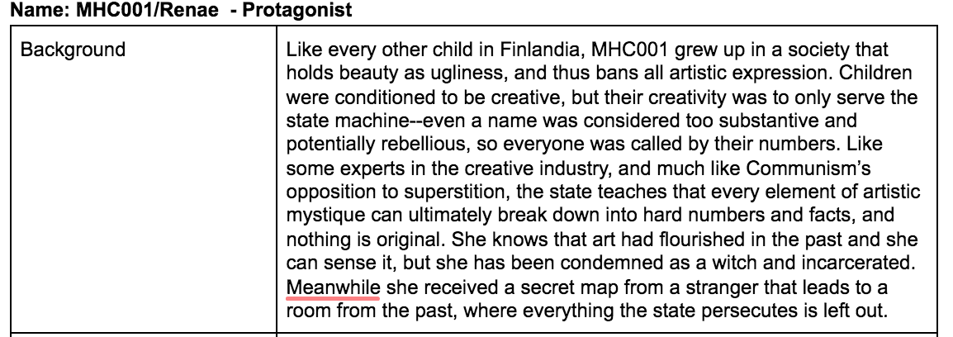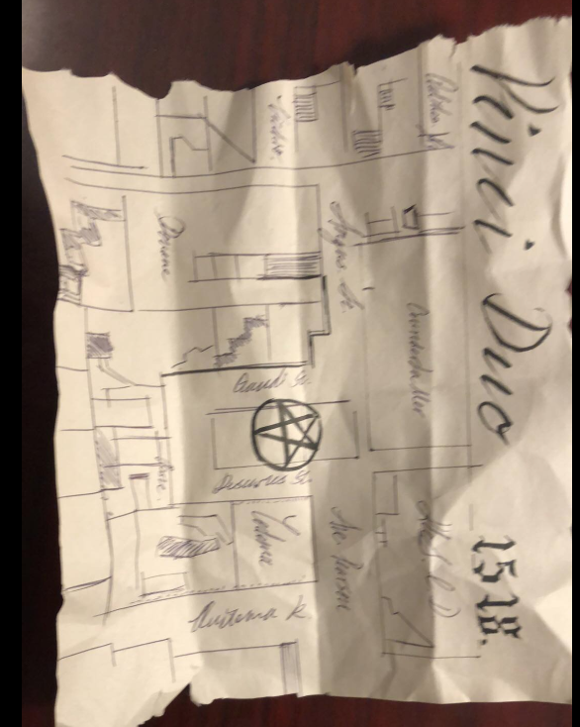
Figure 1: character and props planning
In the planning stage, I worked closely with the screenwriter to draw a character profile, plan cinematography outlooks, and make props. I designed a logo for the fictional country (Figure 1), which was pasted on the cover of D’s creative notebook. The props all revolved around the theme of Angels and Demons, a classical reference to Da Vinci’s time, and I made a vintage map “Vinci Duo” that foreshadows the second discovery of the Renaissance. Still, we never abided by the planned costume and lighting inspirations, because I prefer improvisation as a director and favored minimal retention of backstories once filming starts. This turned out to benefit the film because of the distinctive styles we improvised throughout production and post-production.
The varying tone of the scenes add poignancy to the story. The structure of the escaper - flashback - the pursuer - flashback creates a sense of undulating time that is still moving forward linearly, but it also makes the cross-cutting sequence prone to repetition. So I worked with the cinematographer, sound designer, and editor to set them apart: the camera movement in the sequences of the real world is shaky and contains dramatic zooming, whereas the editing pace is fast and rhythmic. The sound is artificial, loudspeaker broadcasts that blatantly oppose free will; the music is minor key recurrences of dissonant motifs, signifying total control and a coldness. In contrast, the flashback sequences contain faded effects, stable camera movements, and chamber-like sound that indicate a kind of sacredness that is still buried underground.

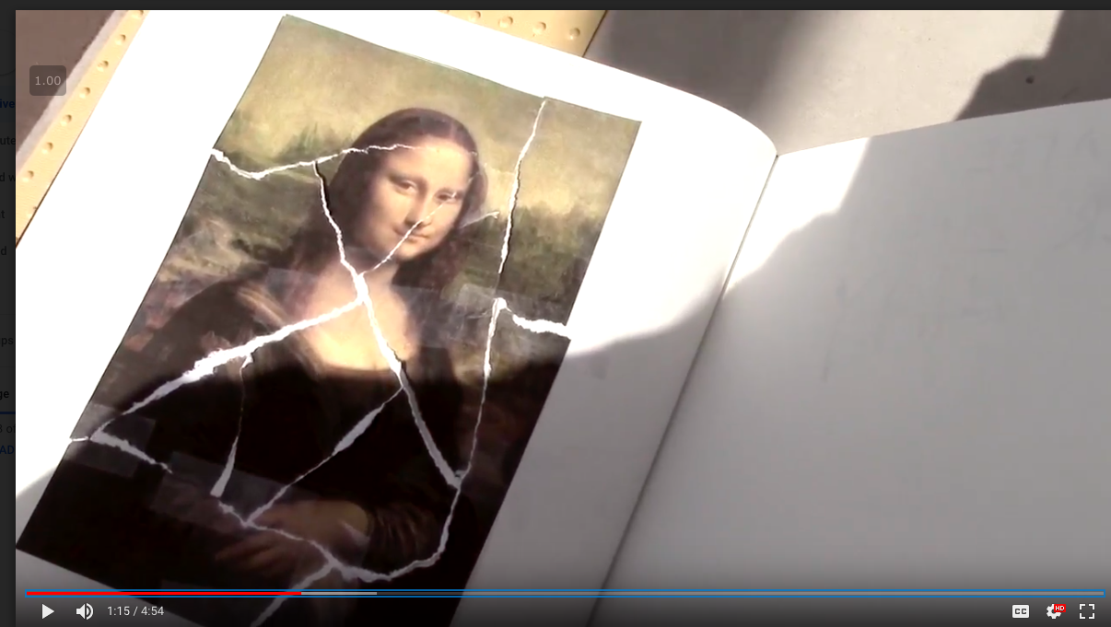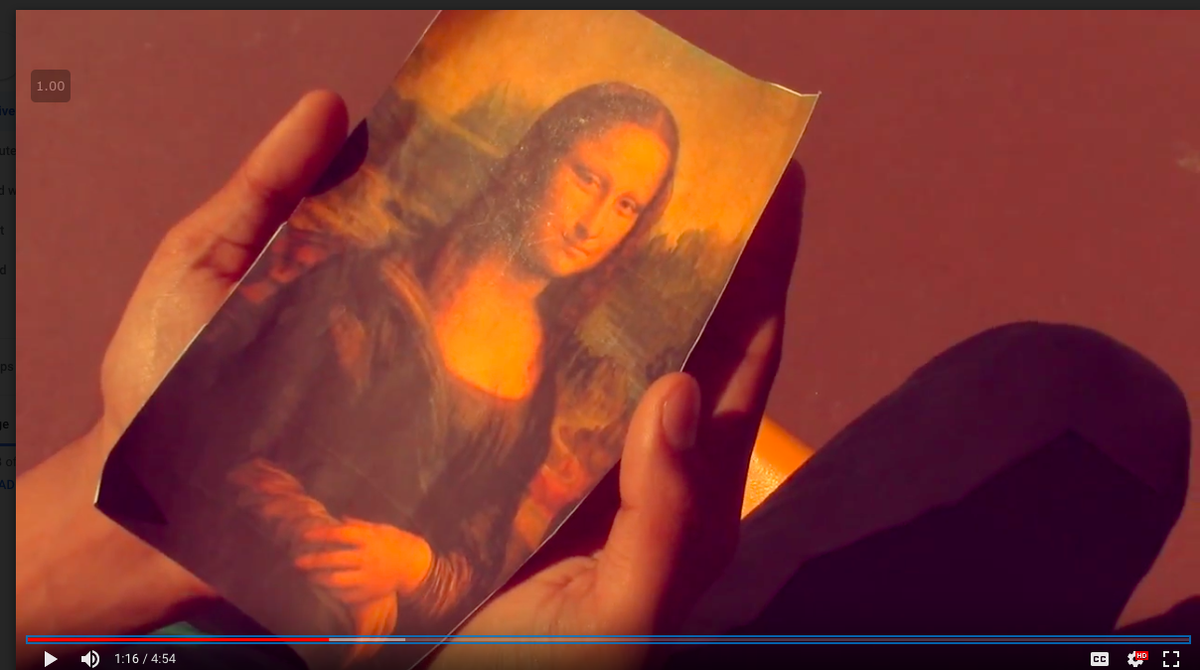Figure 2: graphic match cut + style differences
Graphic match cuts weave these contrasting parts together into dramatize the portrayals of flashbacks. The cinematographer decided to filter the real world with cold and desaturated dystopian colors. The flashbacks, then, resemble faded memory of a warmer time. The Mona Lisa piece D holds corresponds to this contrast: in the flashback it is complete, and in the real world it is shattered, yet it is held in the same proximity and steadiness whether D is a romantic student or a cold hearted agent. This foreshadows D’s revenge to the atrocities done to his dreams.
The audience understood the flashbacks, but they did not understand the significance of space. They were confused about the ultimate purpose of the room, showing that the conflicts in the characters’ life time do not spill over to explain the main structural conflict we wanted to convey. I should improve communication with the screenwriter to find an object of veneration that is relatable to the audience.
Although I was proud of my extensive collaboration with the other crew members and my mobilization of resources, I learned that just manipulating time is not enough and visual cues must be edited into all the scenes to minimize confusion. I also learned to give the actors enough time to soak up their background stories instead of commanding them not to laugh at the seeming absurdity of the plot.

Film 2: Globe (1:31)
The next step on this experiment is a continuation of the father figure through a subliminal connection. If the previous film reveals the connection through flashbacks, “Globe” exploits the filmic privilege of identification to tap into the character’s visions. My inspiration are sequences in A Beautiful Mind (2001) where a brilliant economist suffers from schizophrenia and interact with people others don’t see, as director Ron Howard stated, “trying to create a sense of his psychological state … to show how digital effects have now become a tool, not just of scale and bedazzlement, but also fleshing out character ideas and broadening the possibilities for filmmakers” (Duncan). I want to show that exclusive imaginations, often tragic, not only happen to heros, but those society deems weak such as orphans. This led to the story of an orphan refusing to be taken to the Protective Services Agency because of a vision of her father exclusive to her, citing a snowglobe as evidence. The ending is ambiguous as the shattered globe reappears and her father beckons her. As director, I worked with my crew to ensure that love, heartbreak and hope are balanced well.
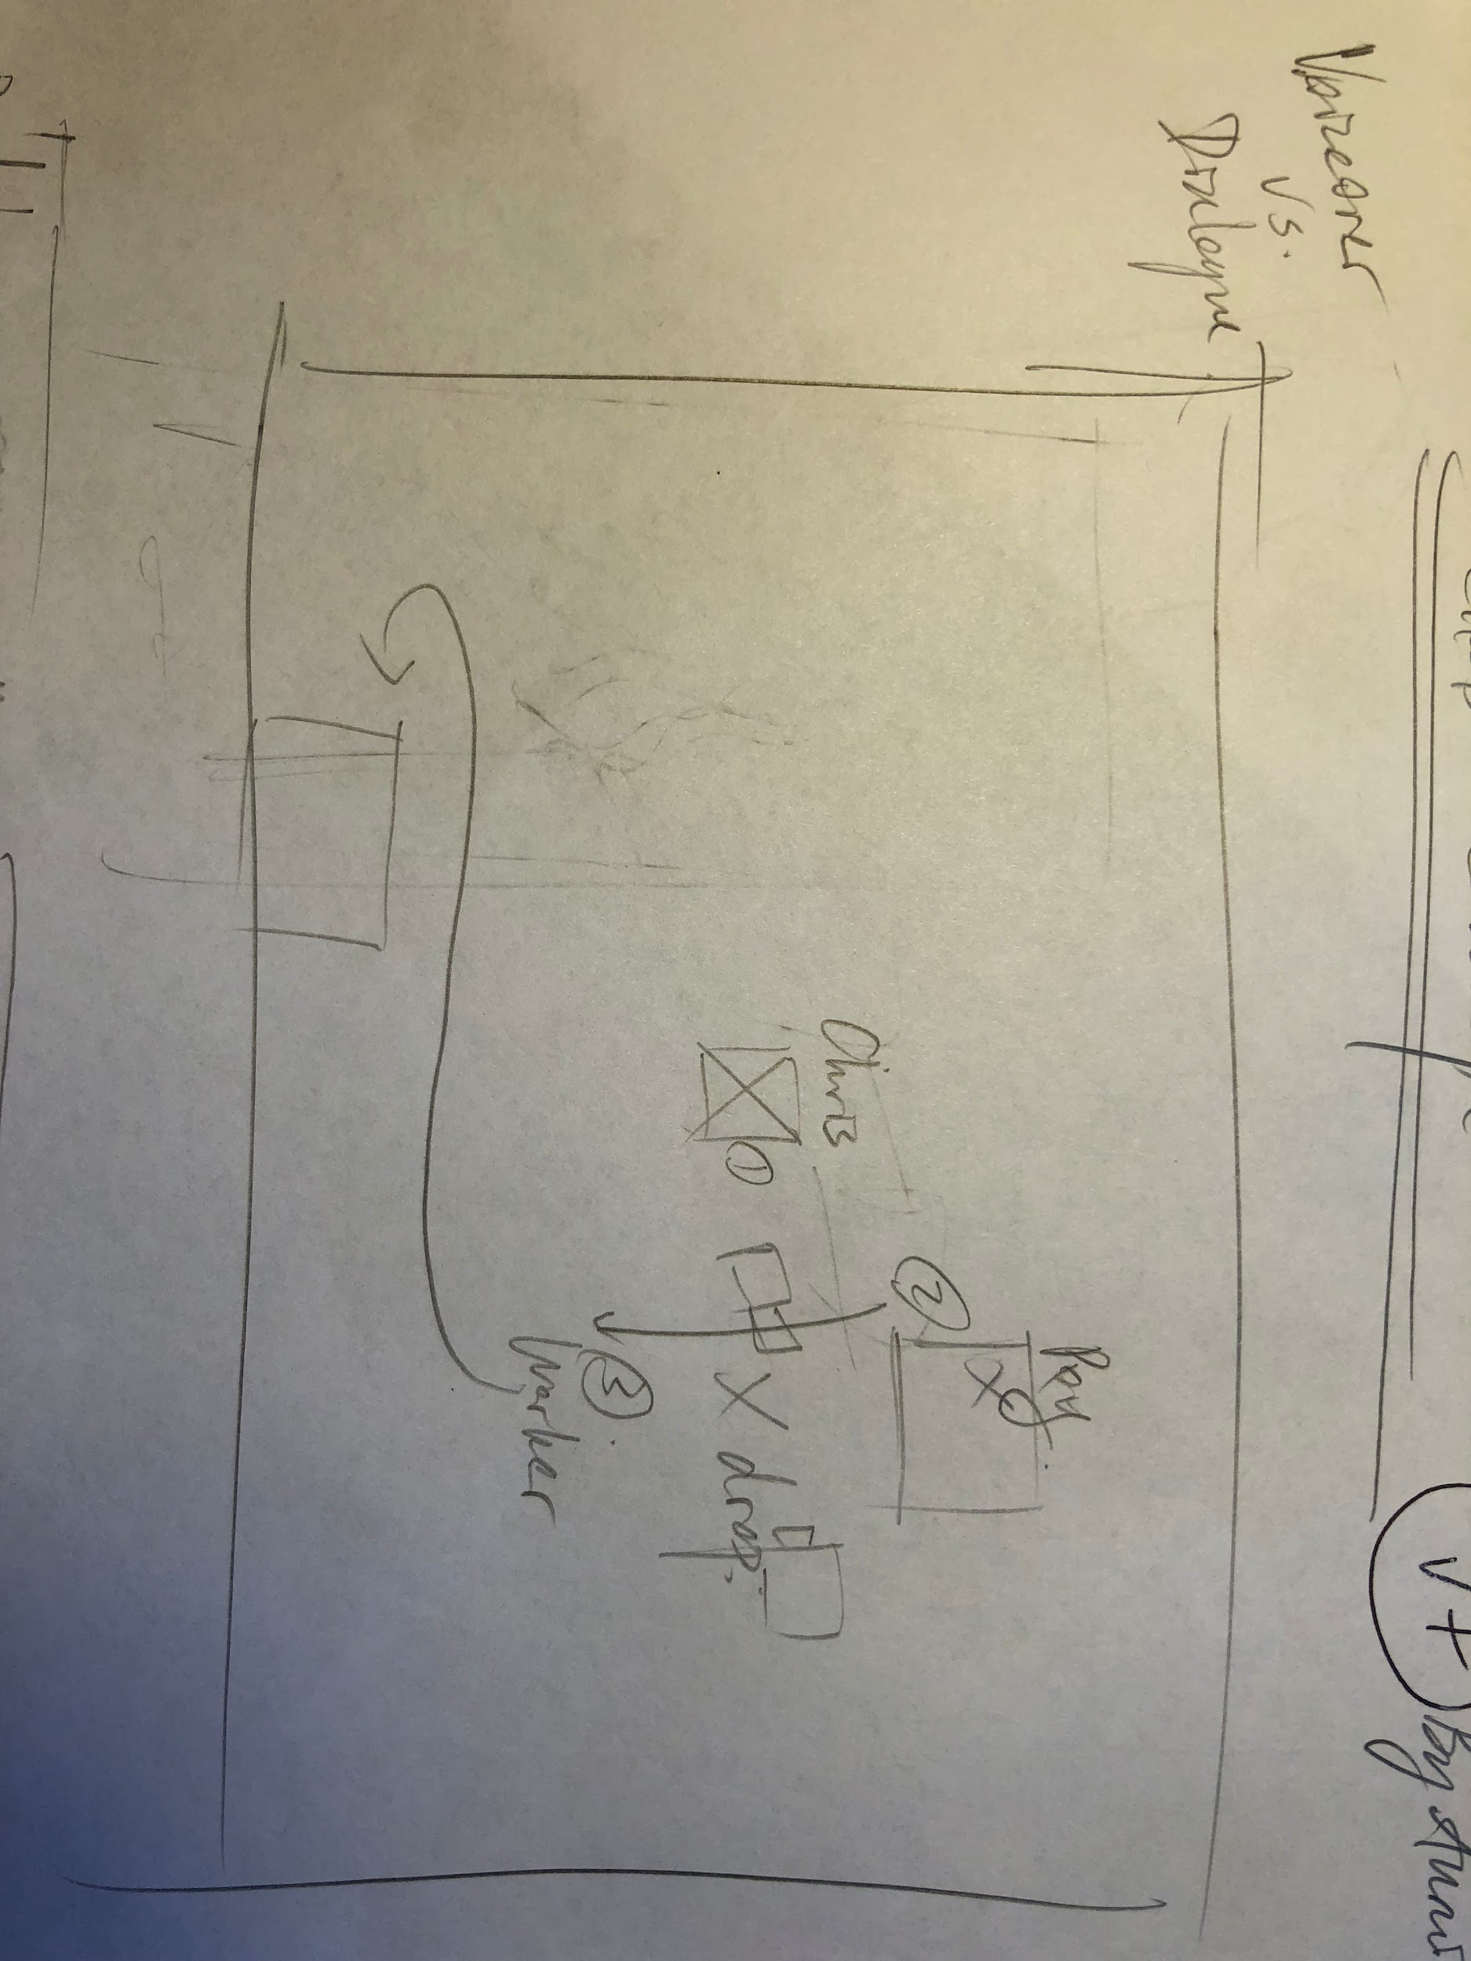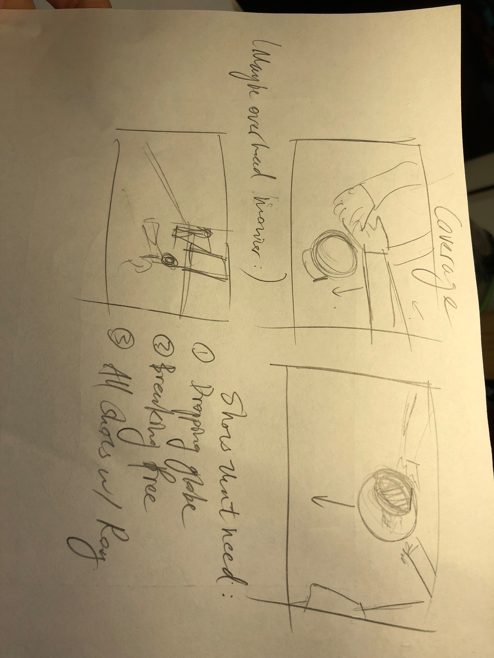Figure 1: position and conceptual planning
The greatest challenge in executing this concept was the sequence in filming. As the same actions from the orphan’s point of view is totally different from the social worker’s point of view, I decided to shoot the version with all three actors before the version without the father. I also chose the setting -- a lounge with large mirrors on two walls -- for its ample supply of poetic lighting, but it posed a restriction on the camera positions available, so I needed to draw them out (Figure 1). I also sketched concepts of some crucial moments such as dropping the globe, and communicated these suggestions to the cinematographer without being restrictive. This is congruent with my directing style overall: leaving at least half of the filming to improvisation, allowing us to take inspiration on set.
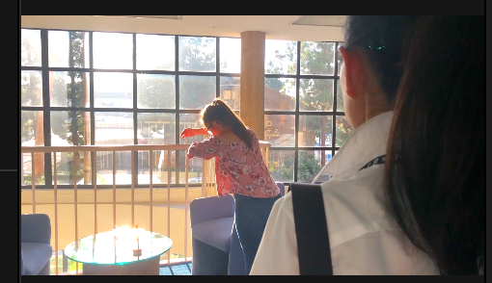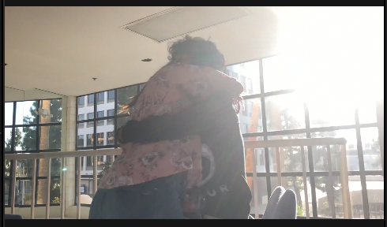Figure 2: exclusive vision
I decided a voiceover would convey the exclusivity of the reunion, as the audience must solely listen to the orphan’s narrative, which I instructed the actor to sound distrustful of the social worker, and an infinite attachment to her father. Furthermore, the voiceover coincided beautifully with the on-screen action, which was unintended when I wrote the script on spot. This gives the film more temporal relevance, as the voiceover is in the past tense, but the speaker seems to be watching the action as well. During post-production, I emphasized the importance of continuity editing, and thanks to this the audience was startled by the transition between the father’s presence and absence (Figure 2). However, a huge flaw that comes with it is the camera constantly crossing the line of action, so that the orphan alternates between facing left and right, and later the globe-dropping sequence gets even messier with the perspectives. This resulted from my unclear direction because we weren’t successful in replicating the positions in the two versions perfectly. I would sketch out the lines next time in the planning stage so that I can have a better mental picture of the viewer’s perspective while filming. The audience also suggested that I explain the ending more, such as why the orphan had to run to another room, so I didn’t maximize the purpose of every action, causing “plot holes” that detract from the message.
Overall, I gained experience in better managing the actors’ time, as this film took only two hours compared to some eight hours in “Deliverance”. I learned that having a unified vision is not enough, rather the attention to detail and technicalities is up to the director as well -- a “paradoxical balance” of the creative and business personality, as one article about Steven Spielberg delineates (McBride).

ROLE 2: Cinematographer
In world film history, even when other stylistics elements are stripped bare by neorealistic movements, cinematography is usually augmented because it sets the tone so effectively (Barsam). I want to exercise the responsibility of radical tone-setting, based on my interests in interface design. In such an article, cinematography “mirrors the cognitive processing of a viewer interacting in the everyday world” (May), and I find it intriguing to tap into the human psyche in unfamiliar situations or an alien world.
My inspirations are Eternal Sunshine of the Spotless Mind (2004) and The Matrix (1999) in which dream sequences are painted with figurative colors and design. Lighting in the films tell more about a world’s “realness” than the narrative themselves. As for traditional cinematography techniques, I would like to explore long shots, because under the trend of cunning reaction shots, it is the long shot that is the most spatially and experientially authentic. Camera movement is also a focus, as dynamic gazing conveys a sense of urgency and intensity rather than set-up modes.
My intention is to explore the differences between realistic and unrealistic cinematography. I find it ironic that cinematographers are responsible for “translating visions into realities” (Barsam), for mise-en-scene is, in my opinion, the most powerful tool, after editing, that transcends reality.

Film 1: Bon Voyage (1:08)
My anti-realistic film draws upon the dream-like aura of European art cinema as well as the theory of Rudolf Arnheim. European art cinema rejects the goal-oriented and fully resolved classical practices in favor of enjoyable but ambiguous productions. like Federico Fellini’s 8½(1963), my film explores dreams and imagination, blending scenes of reality and fantasy. Arnheim stated that “a reduction of depth, a distortion of perspective, an accentuation of perspective overlapping” inherent to films should be the primary contributor to the quality of a film, and antirealistic “defects” are what makes a film “art” (“III-The Film”). My simulation of a non-reality takes the audience on a journey impossible in real life, one I planned magical aloofness with the video.
I carried the spirit of the long shot over with camera movement to create suspense and flight. It is a motif where the characters catch the plane, write a hidden message, stand up, and throw (Figure 1). Despite the challenging long takes for this effect, I managed to center the paper plane consistently, providing a focal point. The choice to pan the camera over the shoulder signals that the character is within a part of a larger mission, the exact content of which is unknown. The camera then follows the footsteps of the characters while tracking the plane. Finally it traces the throw transitions the audience’s identification to the plane, providing a jumpboard for them to be carried into the next scene by the plane motif. At the end, the camera pushes in to a closeup of the message, pulling the audience in as an possessor of the mystery, and completes the cycle of cause and effect delineated by the themes. The editor faced some problems as the shots are unstable, and at one point tried to break the shots off to hide it, but decided to keep it. I need to have these issues in mind when filming, because taking creative risks is magnified on screen.
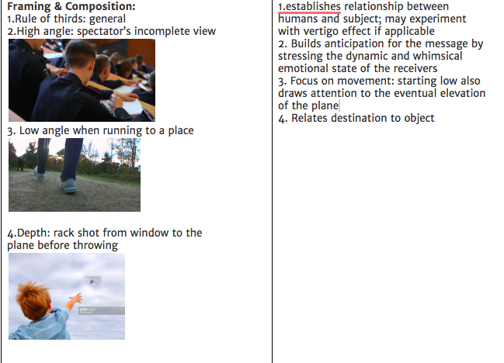
Figure 1: long shot planning: framing, composition, and transition
The framing and lighting aspects of the mise-en-scene contribute to my overall effect as well. Low angle shots of the plane against the sky enhance the sense of flight, but also provides an approximate transitory background. High angle shots of the recipients’ writing on the plane work well with the camera movement to bring out curiosity. A largely outdoor setting provided ample lighting, and contributed the flashing sunlight at the end and beginning of each transition, showing a subliminal and surprising connection while elevating the purpose of the relay into a stellar veneration. Only in the last scene did I prioritize artificial lighting to imply the beginning of a more technical mystery. I should have outlined a better lighting plan and strive to stabilize the contrast and saturation during filming. In terms of collaborating with sound design, I think we did well with the poetry of clamoring and syncing sounds.
When screening, the audience interpreted the gloomy version as supernatural and amazing, affirming my goal to welcome different interpretations under the fantastical theme. They sensed the purposeful connection between the shots, but disputed among the relationship between the worlds--this shows a conflict between my choice of filtering different worlds. They also focused on the cause-and-effect cycle, but are confused by the final revelation, which I need to clarify more, but their reactions to the new plane is typical of reactions to art cinema--interest without understanding.
I learned that I should focus more on set design prioritize stable framing over elaborate movements. That it is important to have precise and realistic visualization of the production, especially in the fantasy aspect. My cinematography should harmonize with the editing to ensure the audience captures intentional mise-en-scene as well as the rhythm of transitions.

Film 2: Jasmine (1:11)
Jasmine depicts a young girl succumbing to peer pressure and drinking. I combined blocking and unusual camera movement to convey the rowdiness of the party environment, but I also fused lighting and angle to highlight the menacing danger.
I filmed a long take of the establishing party scene with a handheld camera, noting its flexibility and experiential authenticity. Inspired by the opening number of La La Land (2016), I determined that a long take involving the camera moving through layers of bystanders is best. The camera follows the toss of a balloon and people partying, and glides through the bully girl’s eyeline to reveal the victim (Figure 1). The red party cup foreshadows temptation and is therefore present in every shot. This shot was devised completely on a whim, so I am dissatisfied by its instability. There was no indication that this was the victim staggering through the crowd as we intended, creating a forced contrast against the later sequence with clear reactions. I could improve by drawing a storyboard and mounting the camera on the tripod to weigh down the shakiness.
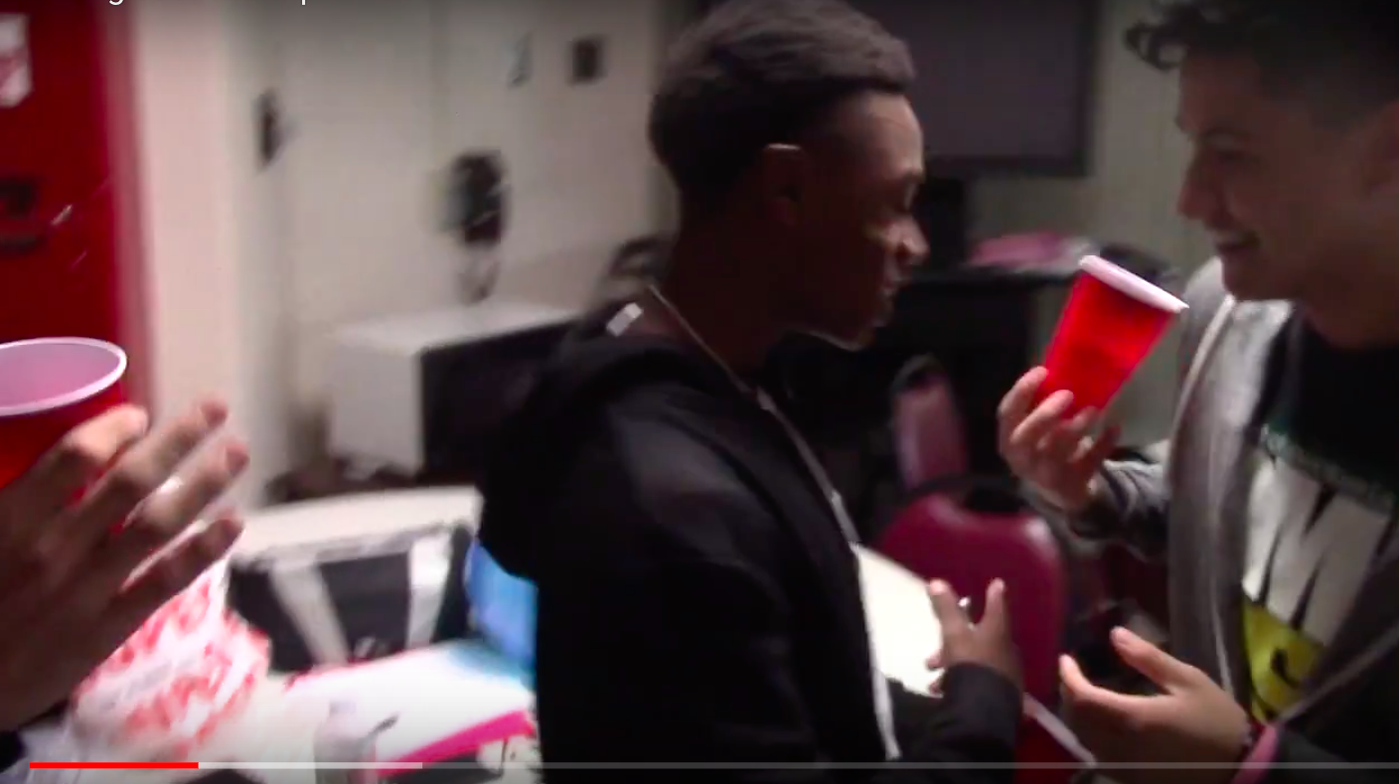
Figure 1: opening sequence, character exchange with red cup motif
I worked with the director to make the choice of cornering the victim. This shows her vulnerability and reduces depth behind her to focus on her plight. Her light-colored clothing and reticent hairstyle contrasts with the bullies’ dark and casual ones, fitting the description of her as a consummate good girl and the rest as ruthless social animals (Figure 1), except the friend that tried to warn her against drinking, who is marginalized in the corner.
Using our only lamp to achieve the lighting effect was more challenging. In accordance with production design, I chose the corner farthest from daylight and adjusted the lamp angle throughout. Although the camera’s shadow interfered with the lighting consistency in the drinking shots, the Halloween lighting coupled with the low angle accentuated the bullies’ menace (figure 1). The closed framing evokes suffocation. However, we could have matched the scale and head space more precisely to show characters’ actual size in the point of view.
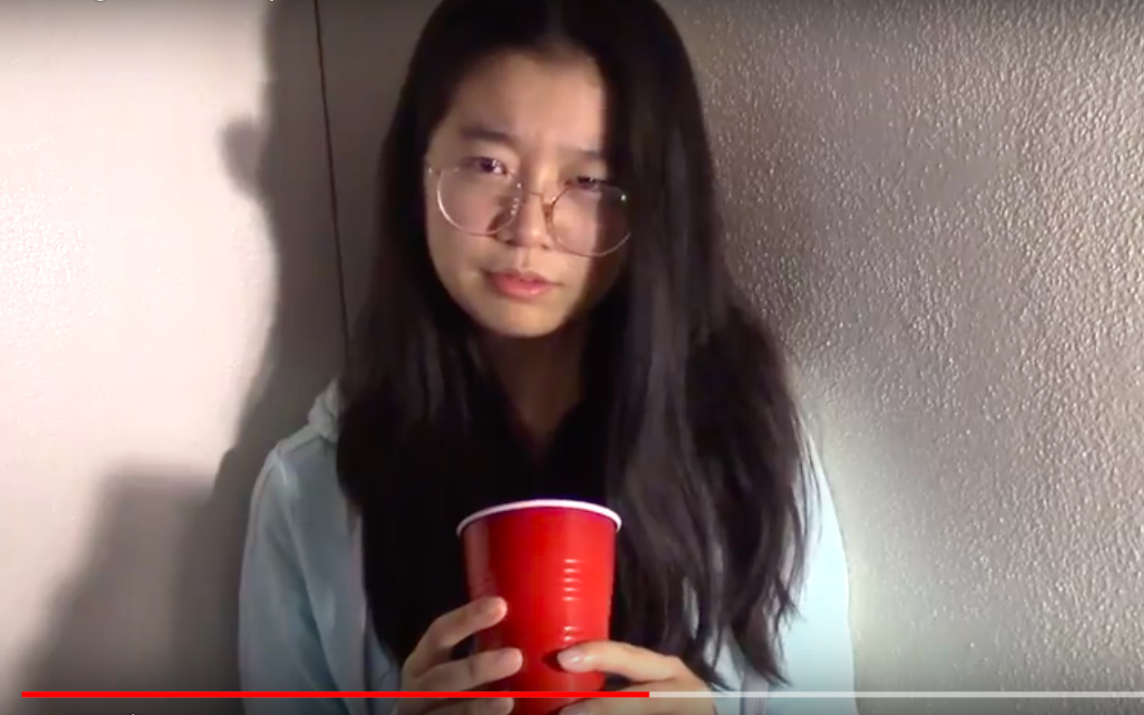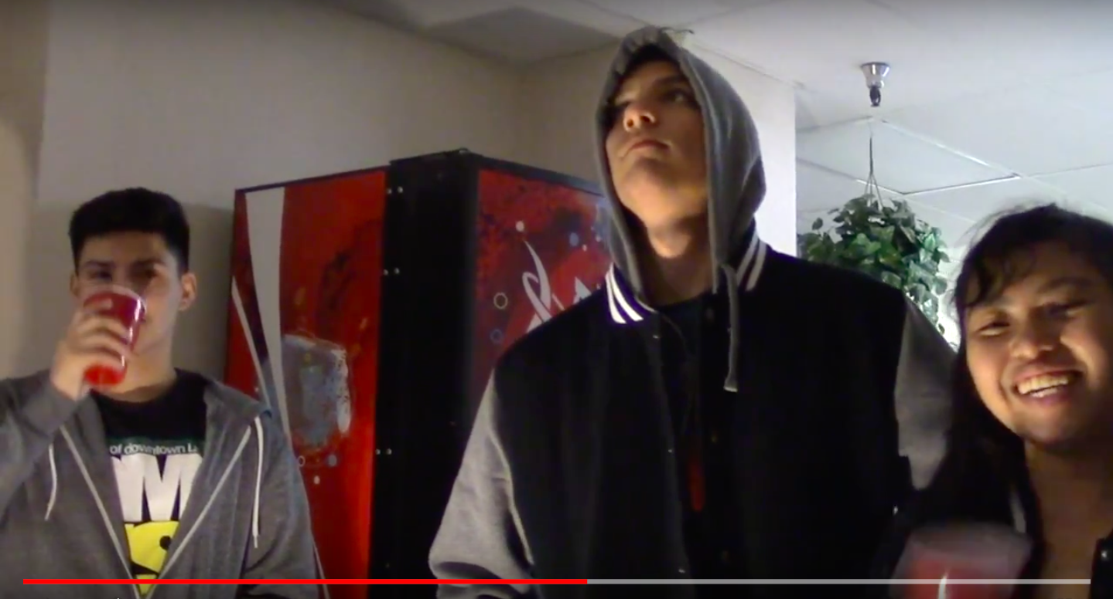
Figure 2: POV shot conveying peer pressure though angle, lighting, and scale
The audience reactions indicate that the tone setting was complete. They understood the chaotic party atmosphere, the blocking, and the effects of color proportions including costume and framing. However, their focus on the opening scene indicates that I could have orchestrated more direct eyeline matches between the actors to show the significance of the victim’s reluctance and the marginalized benign party in the back. The current video only conveys menace without a sense of restitution or warning, and the three bullies lack individuality. I need to improve the composition with the rule of thirds and proximity needs to stay uniform. I will revise our handheld techniques to improve long-take stability, and participate more in the editing process to sort out the spontaneous intentions during filming.
I learned that storyboards are crucial to wasteless filming, because every camera movement would be exponentially magnified on screen. I saw how disorienting positional incoherency can be especially in closeups, and a general aim for the character’s perspective is not enough. Finally, collaboration with everyone on the team and actors necessitates much more planning and collective reflection.

Role 3: Editor
Editors are not merely assemblers, but the controllers of the “creative and expressive powers” of movies (Barsam). I value this control mostly in choosing what to reveal temporally and interpret the response of spatial control as a filmic device that serves convenience as well as a self-conscious style.
I prefer short, energetic, and rhythmic editing over long, emotional, and unmotivated editing. This contemporary interest makes me admire the editing style of trailers for their informational load and musicality. “With trailers, it’s much more style-driven. You can be much more showy—you want to be showy,” says Bill Neil, an editor at Buddha Jones, who also believes that the heart of the trailer is music and sound design (Kitchen). In terms of the precision of alignment with sound, I am inspired by Wes Anderson’s style, his symmetry in his sequence of editing and how the disruption is usually coupled by the sound that gradually builds up but maintains a tempo.
Under that framework, I explored experimental editing on my own. Experimentalism tells a story without a coherent scene, and I like the intellectual challenge of selecting clips not based on continuity but their motion and rhythm.

SMASH (1:02)
My inspiration was Danny Boyle’s opening sequence of 127 Hours (2010), in which split-screen design augments the determined energy of an urban quest. The editor must In expressing the theme of self-efficacy, I continued my rhythm and sound design formula while improving my technical skills, as I made the juxtaposition of shots poetically align with cinematography and music.
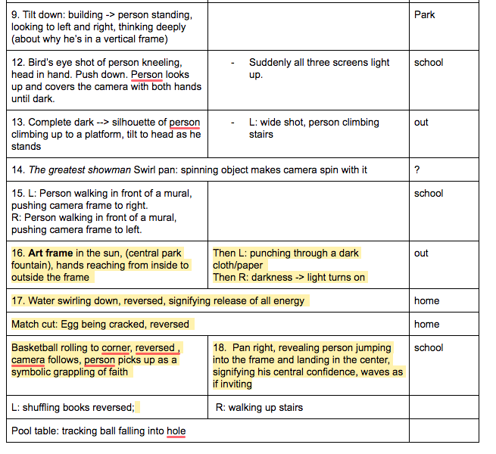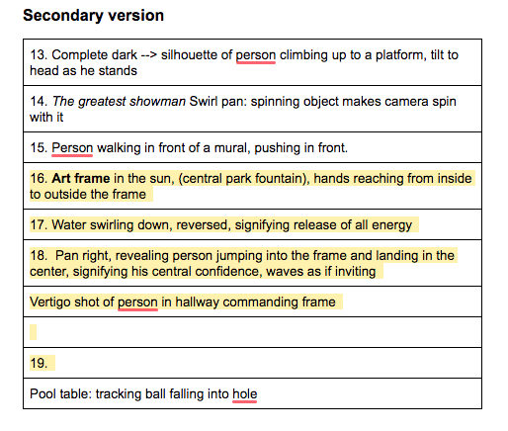
Figure 1: pre-production: primary and secondary versions of editing planning
Although I edited other teacher-led films, this was the first time I incorporated editing into planning, which helped the crew rationalize the filming process. Consistent with my style as director, I left some blank spaces in the shot list and made two versions with and without split screen (Figure 1) for the crew to improvise, as long as they played into the modalities of movement we established in the comment section: slide left, slide right, push the frame literally. This decision worked out well as about 50% of the shots in the final cut were unplanned and inspired by the location.
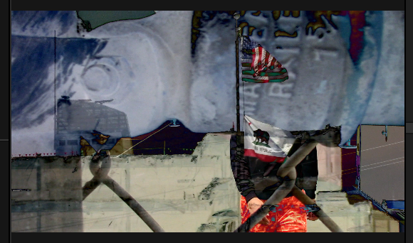Figure 2: technical: overlay
My graphical experimentation like overlays juxtapose personal experience with worldly experience. I inverted the colors of the skyline, which augments camera movement by pairing the push in with the zoom in (Figure 2). This effect precisely blocked out the face of the subject, creating suggestions that social institutions, represented by flags, allow citizens to survive. The pipe that covers the person’s face now becomes the sky, a metaphor for the pipeline of careers people labor for. This summarizes the exposition part: “Life is coming at you. You are the target”.
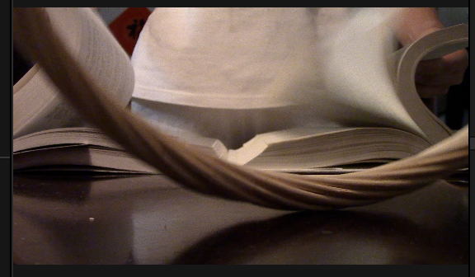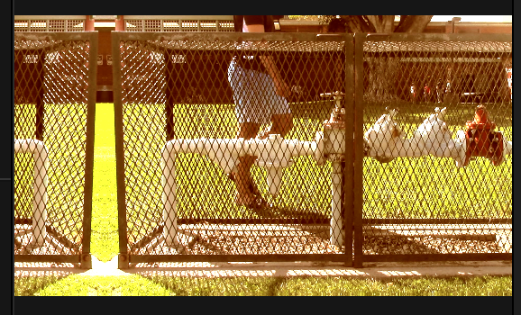;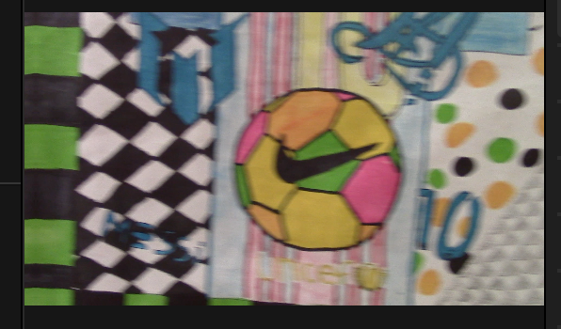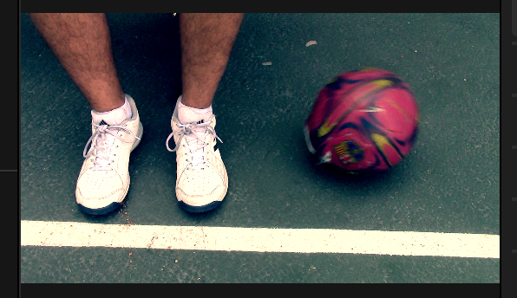
Figure 3: motion + graphic match
In comparison, my choices of transitions are more stylistic in stitching together a narrative devoid of spatial-temporal continuity. The rhythm of the transitions aligns with musical elements, compartmentalized and constant ones alike. The fleeting high arpeggios complete a flight every time a different object falls into its destiny, signifying the dissonant dullness of life. I worked with the sound designer to ensure that the bass line goes uninterrupted by the individual tunneling, in order to create a larger tunnel consisting of the endless repetition of life. I also used an externally downloaded Slide tool to edit shots with similar motion together: the wheel rolls to the right, slide right, and the person continues the motion from screen left again. This is also seen when the music intensifies and I “slide” the artwork ball into existence (Figure 3), indicating that fatalism is not an illusion but a tangible fact. The motion are inspired by the Soviet Montage movement, for instance Sergei Eisenstein’s theory that a montage is “an idea DERIVES from the collision between two shots that are independent of one another” (Lindop). But upon viewing I realized that my version is too self-conscious to create substantial meaning “between shots”. This is made worse by the final voiceover that generalized a group of the shots and counteracted the previously discussed force of the music. This be remedied next time by working with the sound designer better to avoid sound intruding into the imagery
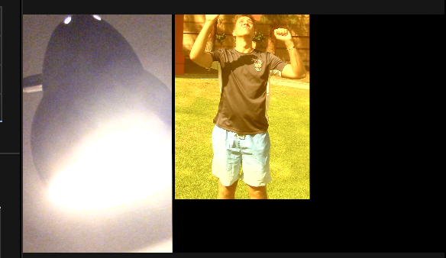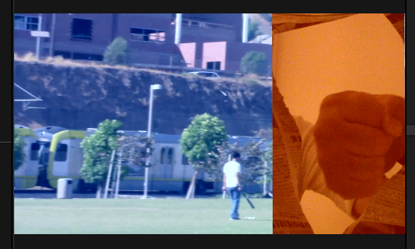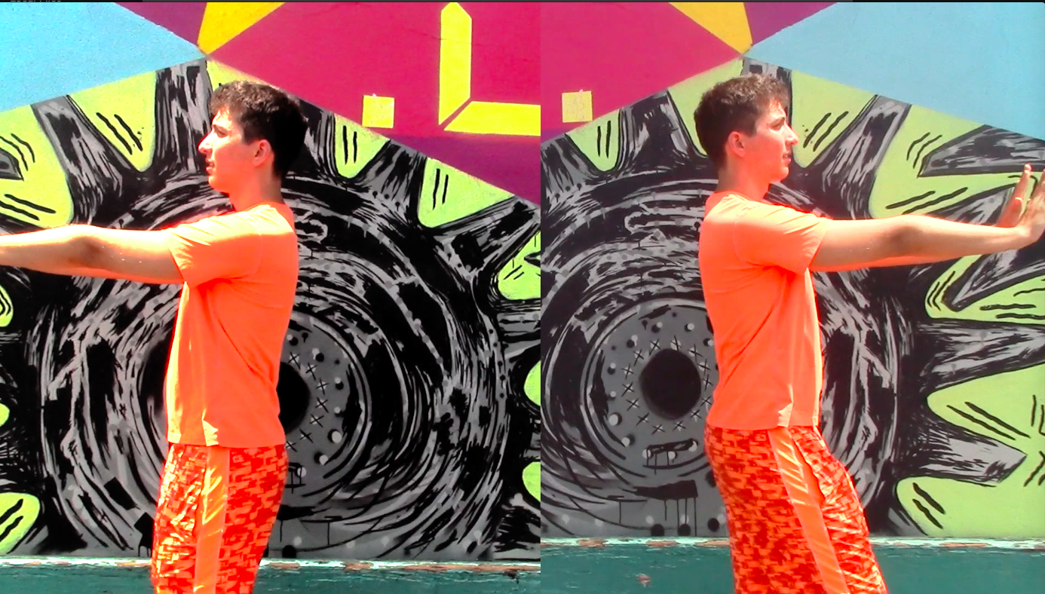
Figure 4: splits staging and motion
I am proudest of the split screen effect for its metaphysical meaning, a burst of outlook on seizing the day. The pre-planning documents worked best here: although the content of the shots varied pragmatically, the dynamics of the left and right screens maintained the vitality. I determined that iMovie could not satisfy this creative ambition and shifted to Final Cut Pro X. Through experimenting, I discovered beauty in the roughness of the split screen: having the audience be aware of how images ebb and flow on a dark screen aligns the with the spirit of the voiceover: “turn your life around, literally”. The loose piano music that the sound designer personally played recalls home-made films, such as the one at the end of La La Land (2016) where an alternative reality is shot and put together casually. This served as inspiration for the dynamic. In post-production, I worked with the cinematographer to juxtapose light and dark images as well as warm and cool color corrections. The breaking of frames are always in warm color, signifying the power of inner warmth in change-making.
The kinesis I calculated precisely to present a self-conscious, theatrical effort of realism: the trapped one pulls from above and the light turns on; the moving train represents the person’s effort to escape the frame, while the fist breaks out, a symbol of puncturing (Figure 4). The frame metaphor is a deliberate tribute to breaking the fourth wall. Through this, I gained the skills of not only editing across time, but also editing across dimensions of reality. The audience would not understand the frames as literal examples of taking initiative in life, but they would identify with the character nonetheless because they can now see their reality as frames as well.
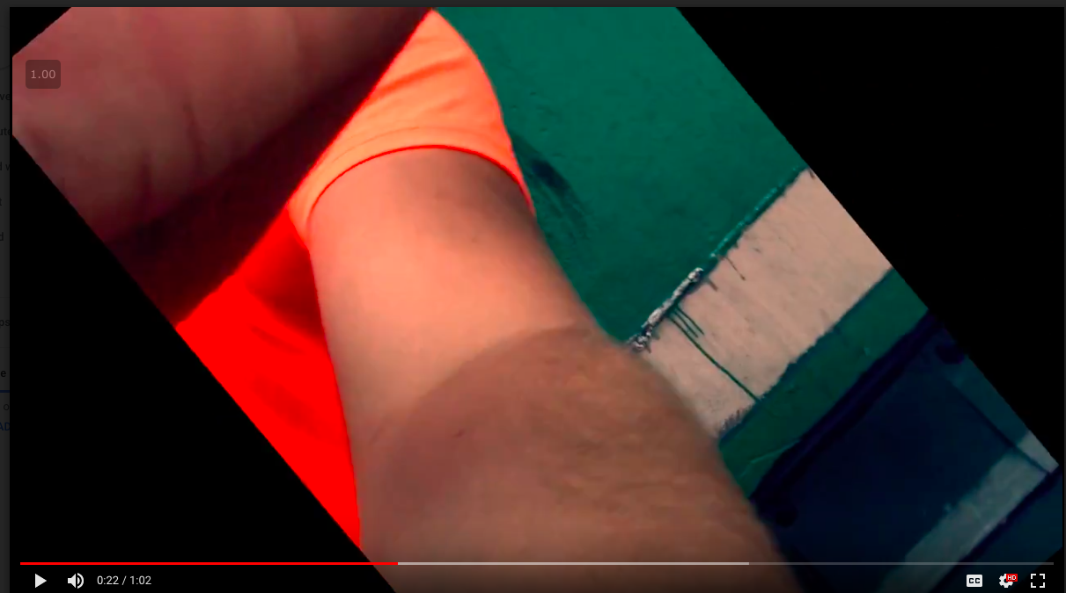Figure 4: “turn your life around” flaw
However I need to avoid letting stylistic attempts override narrative coherence. Improvisation was central to the film, but also encouraged me to insert random effects at the wrong time. The screen rotation effect took a significant amount of research to achieve, but its following frames contain three references to the same action: covering the screen, voiceover, and a vertical composition. This mistake disrupted the gradual transition from the gloomy to the glorious, causing an unintended comical reaction in the audience. Experimental editing should be self-conscious, but not glib enough to detract from the theme.
Upon screening, the audience found the editing fun but the sequence too intellectual. I could have been more cognizant of audience understanding and eliminated some of the sped up clips, even though it requires further negotiation with the sound designer. But the graphic match cuts caught the most attention for their referential strength.
I learned that technical skills is a prerequisite for creating experimental shorts: this film finally prompted me to upgrade to Final Cut Pro X, and I learned much from the online communitY of filmmakers. I learned that planning with other team members on the editorial vision works best; that planning does not necessarily have to interfere with filming needs, but it must address post-production as well.

Works Cited
Barsam, Richard Meran, and Dave Monahan. Looking at Movies: an Introduction to Film. W.W. Norton & Company, 2016.
Duncan, Phillip. “Ron Howard - Director of A Beautiful Mind.” DVD Talk, 2001, www.dvdtalk.com/interviews/ron_howard_dire.html.
Cowell, Henry. “The Banshee”. MP3.
“III-The Film Medium: Image and Sound.” Film Theory and Criticism, by Leo Braudy and Marshall Cohen, Oxford University Press, 2004.
Greydanus, Steven D. “Hollywood’s Treatment of Fathers.” The Catholic World Report, 2011, www.catholicworldreport.com/2011/05/06/hollywoods-treatment-of-fathers/.
Kitchen, Matthew. “Meet the People Who Grind Out the Best Movie Trailers in the World.” The Ringer, The Ringer, 23 July 2018, www.theringer.com/movies/2018/7/23/17601024/movie-trailer-editors-marvel-pixar-how-made
Knight, Chris. “Isle of Wes Anderson: Exploring the Director's Distinctive Style, from Cast to Colour.” National Post, 26 Mar. 2018, nationalpost.com/entertainment/movies/isle-of-wes-anderson-exploring-the-directors-distinctive-style-from-cast-to-colour.
Lindop, Jason. “Eisenstein: 'Intellectual Montage', Poststructuralism, and Ideology.” Offscreen, 2007, offscreen.com/view/eisenstein_intellectual_montage_poststructuralism_and_ideology.
May, Jon, and Philip J. Barnard. “Cinematography and Interface Design - Semantic Scholar.” Film Theory at Interact '95, 1 Jan. 1995, www.semanticscholar.org/paper/Cinematography-and-interface-design-May-Barnard/52169a1457f55636ed62d4e038c8d7c26bdcbfbc.
McBride, Joseph. “Steven Spielberg: Control Freak and Collaborator.” The Washington Post, WP Company, 24 Feb. 2012, www.washingtonpost.com/national/on-leadership/steven-spielberg-control-freak-and-collaborator/2012/02/22/gIQAVEUsXR_story.html?noredirect=on&utm_term=.9812efd38dc2..
Sound Effects. Soundbible.org, Works under Creative Commons License. Web. 19 Feb 2018.
Sound Effects. Looplabs.com. Wav file. Works under Creative Commons License. Web. 28 Sep 2018. https://www.looplabs.com/studio

